Sure, first thank you for this opportunity, I would summarize my job into 2 parts

As data scientist, I would proactively work with relevant stakeholders, sales and consultants to ensure that concepts being proved are appropriate for purpose and market needs and have the required level of technical feasibility

I’m also involved in the Design and implementation of new analysis or model development techniques with benefits to the firm through greater predictive power, standardisation, speed, simplicity or automation.

**Tell me what you do?**

In short,

Reframe consultant, sales persons and stakeholders’ domain questions as machine learning task for the analysis. Thereafter, humanise the data by turning row numbers into a story about performance and KPI metrics. Transforming the analysis into understanding of business team and stakeholder’s quarries. Providing them with the very best thinking and leadership in creating meaningful, measurable marketing experiences

I also spend a lot time on developing project briefs and proposals. Building presentation providing the clear analytics and insights story – why the work is important, the truths that the analytics reveal, and the actions that should follow the analysis.

**Modelling best practice**

**Setting up a Model**

1. Involve key stakeholders: be sure that all elements of the marketing plan are understood and incorporated and to confirm that the objectives for the effort align with the analyses being performed.
2. Ensure that there are sufficient data available and that minimum spending levels are met to enable statistically reliable outputs.
3. Align inputs to data being reported for results as much as possible, looking at factors such as: — Interval of reporting
4. Consider assessing factors that may affect marketing results and incorporate this thinking into the model — Saturation: — Creative: Halo Effect Synergy Short-Term Effects Trends:
5. Consider how modelling outcomes may fit with results from other analytic tools — brand awareness, Purchase funnel analytics.

**Interpreting Model Results**

1. involve all the key players to discuss the learning and provide the most comprehensive insights regarding modeling results and implications
2. Allow for multiple opportunities for data interpretation. Presentation of the initial results will likely raise questions that additional analyses can help to answer.
3. Consider modeling as a tool to understand the cause and effect of marketing, not an answer in itself. Seeking to understand why the results came out the way they did can be the key to making the most effective decisions going forward
4. Assess the role of each medium relative to results.
5. Consider how the analyses handle media with relatively low spending so their impact is not lost by media with larger budgets

**Tell what you do?**

As a senior analyst, I would summarize my job into 2 parts;

1. Data wrangling & modelling (70%)
2. The remaining 30% on business integration and insights.

In short I’m tasked with humanising the data by turning row numbers into a story about performance and KPIs. Transforming numerical model outputs into an understanding of business team and stakeholder’s quarries. Providing them with the very best thinking and leadership in creating meaningful, measurable marketing experiences.

**Reframe consultant, sales, stakeholder domain question as machine learning task.**

**xxxxx**

Developing project briefs and proposals. Building presentation providing the clear analytics and insights story – why the work is important, the truths that the analytics reveal, and the actions that should follow the analysis.

# Where Do You See Yourself in Five Years?

My goal right now is to find a position at a company where I can grow and take on new challenges over time. Ultimately, I’d like to assume more management responsibilities and get involved in product strategy. But most importantly, I want to work for an organization where I can build a career*.*

# How Do You Handle Stress / Pressure?

* I react to situations, rather than to stress. That way, the situation is handled and doesn't become stressful.
* Prioritizing my responsibilities so I have a clear idea of what needs to be done when, has helped me effectively manage pressure on the job.

# How do you deal with conflicting deadlines?

Conflicting deadlines are a normal. I resolve the conflict by using the time frames as the reference, and scheduling for completion according to needs. I would complete each job systematically, so I stay organized, and on time.

It's an effective method of dealing with conflicting deadlines.

In some cases, the deadlines can't be resolved like this. In those cases I ask for guidance from management.

## **What was a typical day like at your most recent job?**

As analyst there is no typical day, my work varies greatly from day to day. As mentioned earlier 70% on data and modelling, the remaining 30% involves meeting, writing up presentations and insights.

**How can you add value to our company?**

**How do you handle difficult stakeholders and stakeholders resisting change?**

We both want the project to succeed, therefore keeping an open communication that provides them with the clear analytics and insights story – why the work is important, the truths that the analytics reveal, and the actions that should follow the analysis.

**Accomplishments**

I’m proud and highly interested of what I do, my main accomplishments are primarily in three areas;

* Model Developments: I contributed significantly, to the development of Prophecy. In 2012, Forethought was awarded the AMSRS Innovation in Methodology Award for Prophecy Feelings the frame-breaking quantitative method for revealing the hierarchy of rational and emotional behaviours, which enable marketers to activating emotions at brand and communication level to drive consumption.
* Analytics and insights: ADMA 2014, finalist for Cross channel Analytics (revealing the hidden relationships between media Channels offline and digital).
* Data management and Dashboards: Built and designed dashboards that humanize big data by turning row numbers into KPI performance metrics.

**For example,**

**Kmart** commissioned my company to undertake a quantitative study of Australian department store. A market that was declining by 3.7% (ABS), the methodology used was Prophecy Thoughts (quantitative measurement of rational drives) and Prophecy Feelings (quantitative of discrete emotions).

Emotions: Do you always need to be “positive”? How quickly can emotional response change and what causes people to lose interest in ads? What styles of ads create the best emotional response? What kind of messages, celebrities or execution elements work best to evoke emotion and drive purchase interest and recommendation?

**Business objectives**

1. To increase gross margin growth within the department store category
2. To achieve YOY transaction growth of over 4%
3. To increase store traffic by greater than 2.5% (in a declining market)
4. To increase loyalty as measured by consumers shopping

**Outcome**

1. Product sales up 25 mil
2. Customer traffic up 3 mil in the six month
3. EBIT up 5.8%
4. Was in the Financial Review
5. ARF(Advertising Research Foundation) awards at New Work

**For example, Subaru** has commissioned us to help the national marketing team to strategically allocate and optimize their marketing budgets across channels

**By understanding,** that the media landscape is ~~changing~~ has changed

1. Google’s advertising revenue is bigger than that of the entire US print industry.
2. Amazon’s annual revenue is greater than half of the word’s GDPS.
3. Facebook has nearly half of its 150 million daily visits from mobile.

For this reasons, we developed a methodology called POEM, a statistical methodology that leverage POE interactions to drive higher ROI.

**To answer**

1. Which marketing drivers have had the greatest effects?
2. What is the return on investments of Subaru media activities?
3. What's the influence of price on Subaru sales?
4. How much have they made through advertising?
5. Are they optimally allocating their budget across products?

**Why you leaving your current job?**

To be honest, I wasn't considering a move, but, after going through the job description I was intrigued by the position and the company. It sounds like an exciting opportunity and an ideal match with my qualifications.

**Ask question**

* What Kind of challenges are you facing at the moment?
* What makes a person successful here? or
* What kinds of challenges will I be able to help with?
* “If Inivio is the marketing division of Verda, how do they interact with analysts?
* In an increasing digital world – 3 in 4 Australian’s browse the internet while watching TV- , and Inivio being an offline marketing do you find it challenging to explain the important offline marketing to drive online media?
* Roy Morgan has something similar to landscape,
  + Helix Personas: Based on psychographic and behavioural data to classify the Australian population into 56 segments and 7 Communities.
  + Landscape: 41 segments and 13 groups.

**Why move from academia to industry?**

The career path that I have taken has been full of challenges and has required adaptability, resilience, and persistence. However, it has been extremely rewarding, and I feel fortunate that, in my career, I have had the opportunity to gain exposure to complex industry problems, to learn about data and modelling, to utilize both my technical ability in statistics and non-technical skills such as engaging with senior business stakeholders.

**Attribution model**

Awareness drivers and convertors are revealed by reassigning a value to every exposure based on its position in a conversion path. Values are reassigned based on three coefficients: 1) the likelihood of an exposure appearing in a convertor path and 2) the time between exposure and conversion 3) The frequency at which a digital tactic appears in the path. This results in an optimization tool that identifies the most efficient media at the most granular level.

**Social Network analysis, using Bayesian Network, Decision Trees and SVM. +**

**Implement and improve Connection Stories based on survey data and statistical models.**

**CART (Classification and regression tree)** Used to explore the structure of a data set, determine the split based on logical if-then conditions that would allow to accurately predict.

**Propensity models**

Use scorecard to predict customer behaviour. Based on the objective;

1. Propensity to convert (likelihood to take an offer)
2. Propensity to churn (which costumers are at risk) focus on retention.
3. Propensity to engage.

Used often to identify those most likely to respond to an offer, or to focus retention activity on those most likely to churn.

1. GLM model 🡪
2. PS = fitted(glm) Propensity score , Y= data$Y depended variable , Tr= data$treat treatment indicator.
3. Mathit( Y=Y, Tr=Tr, X= PS, Method =”full,neighbour”)
4. covariance balance check.

**CART (Classification and regression tree)**

Used to explore the structure of a data set, determine the split based on logical if-then conditions that would allow to accurately predict.

1. rpart
2. ctree, conditional inference tree
3. prune the tree, avoid overfitting the data.
4. randomForest, impove predictive accuracy by generating a large number of bootstrapped.
5. SVM (Support Vector Machines), with an appropriate kernel they can work well even if you're data isn't linearly separable in the base feature space. SRM (structural Risk Minimization)

**Customer segmentation – LifeCycle Grids with R**

It is based on customer’s lifecycle, specifically on frequency and recency (RFM) of purchases. We are interested in frequent and recent purchases, because frequency affects client’s lifetime value and recency affects retention. Therefore, these metrics can help us to understand the current phase of the client’s lifecycle. When we know each client’s phase, we can split customer base into groups (segments) in order to:

* understand the state of affairs,
* effectively using marketing budget through accurate targeting,
* use different offers for every group,
* effectively using email marketing,
* increase customers’ life-time and value, finally.

Based on analysis of distribution of frequency and recency values through our data set jointly with knowledge of business aspects can help us to find suitable boundaries.

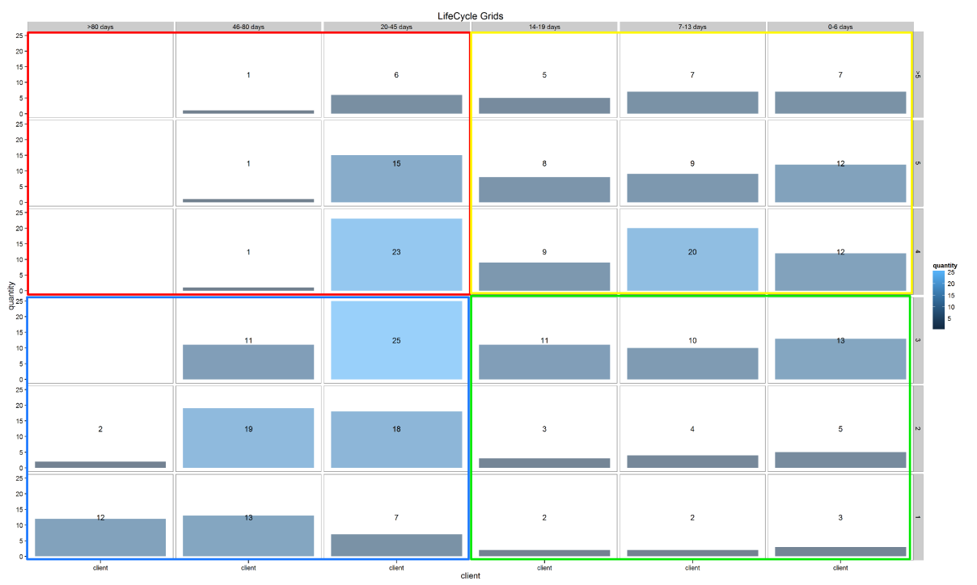

* **yellow** – here are our **best customers**, who have placed quite a few orders and made their last purchase recently. They have higher value and higher potential to buy again. We have to take care of them.
* **green** – here are our **new clients**, who placed several orders (1-3) recently. Although they have lower value, they have potential to move into the yellow zone. Therefore, we have to help them move into the right quadrant (yellow).
* **red** – here are our **former best customers**. We need to understand why they are former and, maybe, try to reactivate them.
* **blue** – here are our **onetime-buyers**.

## Sample Situational Interview Questions with Answers for management positions

The following are examples of answers to managerial situational based interview questions and answers:  
**1. Question:** You are introducing a new policy into the team or group. You are facing a bit of opposition. How would you handle it?  
 **Answer:** On principle, I would introduce any policy very gently. If feasible, I would hold a small meeting of the group that is affected and introduce them to the policy, as well as take the time to inform them of the advantages they and the company would obtain once the policy is in place.  
Also, I would stress the fact that the policy is not a hard and fast rule and it may be reworked if the people are not completely comfortable working under such a rule and policy.

**2. Question:** Your team is working on a very sensitive project which is on the verge of completion. Another project comes in which is very important. How would you set your priorities?  
 **Answer:** The first thing that I would look into while taking a new project is the learning curve that would have to be generated. If the learning curve is too high, I would give the assignment to a senior, taking the work that he or she already has and give it to a junior resource.  This way, the new assignment will be worked on side by side with the old assignment, enabling simultaneous implementation of both assignments.

**3. Question:** There has been a visible decline in the performance of a subordinate. How would you handle it?  
 **Answer:** First off, I would try to investigate the reason behind the decline of the subordinate’s performance. Once the reason is discovered, I would decide whether the reason is professional or personal. If it is a professional reason, I would then try to find out whether I can solve the problem that the person has been facing.  
If it is a personal problem, I would keep an eye on the time that the person has lost due to the personal problem. If the time taken cannot be handled by the company, I would speak to the person about the same, and give him an idea that he or she should try to solve the personal problem on his or her own, so that productivity may be increased for the company.

**4. Question:** It is the year end and there is a big backlog of work for everyone. One of your co workers informs you that he or she plans to take the week off, while claiming sick leave. How would you counter the situation?  
 **Answer:** I would first think about the past progress of the co worker. If the co worker has had a minimal amount of holiday during the entire year, I would neither support him nor report him – I will change the week off status to vacation leave. However, if the co worker has a history of taking casual leaves under fake reasons, I would report the matter to the HR.